Electrical Installation

General Information

To comply with Underwriter Laboratories (UL) and Canadian Standards Association (CSA) certification, route signal leads and power cables in earthed (grounded), flexible metal conduit.
- Instruments not fitted with the optional internal on/off switch and fuse must have a disconnecting device such as a switch or circuit breaker conforming to local safety standards fitted to the final installation. It must be fitted in close proximity to the instrument within easy reach of the operator and must be marked clearly as the disconnection device for the instrument.
- Remove all power from supply, relay and any powered control circuits and high common mode voltages before accessing or making any connections.
- Use cable appropriate for the load currents. The terminals accept cables up to 14AWG (2.5mm1).
- The instrument and all inputs and outputs conform to Mains Power Input Insulation Category ll.
- All connections to secondary circuits must have basic insulation.
- After installation, there must be no access to live parts e.g. terminals.
- Terminals for external circuits are for use only with equipment with no accessible live parts.
- If the instrument is used in a manner not specified by the Company, the protection provided by the equipment may be impaired.
- All equipment connected to the instrument's terminals must comply with local safety standards (IEC 60950, EN601010-1).
NOTE:
In order to ensure maximum performance from ERC-900 series Ethernet based remote Relay, proper wiring installation practices must be followed. Failure to do so can result in a range of problems, from loss of configuration to component failure, caused by transmitted or radiated electrical noise. Proper consideration must be given to local noise sources and appropriate suppression steps taken to minimize any potential problems. Among the most common sources of noise are: Relays, SCRs, valve solenoids, electric motors, power line disturbance, wire-to-wire coupling, electrostatic discharge (ESD) and radio-frequency interference (RFI).
To achieve the best results, the following notes should be considered:

- Signal input wiring should be twisted pairs/triplets etc. The conductors should be stranded rather than solid in construction. All signal wiring should use ground-shielded wires, or be routed through grounded conduit to minimize the effects of RFI and ESD.

- Special care should be taken when wiring to relays, as large transients are produced when coils are switched. This problem can be eliminated by the use of suitable suppression devices across the relay. Relay transients can also be transmitted through the air, so the device itself should be mounted as far as possible from power control devices and/or wiring.
- When line power is poorly regulated and / or subject to voltage surges or transients, consideration should be given to the use of a line conditioning/transient suppressing line power regulator. Process control motors, valves, relays and heaters should not be connected to the same power lines that are used for instrumentation.

- All local electrical codes of practice must be followed when installing any instrumentation.

Mains Supply Installation

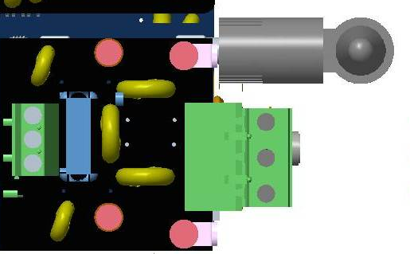
Earth
Neutral
Line

Figure 1 Mains Supply Connection
Note: The color of the text box resembles the color of the wire.
In the ERC-900 series Ethernet based remote Relay, power supply connector is on the supply add-on card, instead of direct on control board as shown in figure 5. Full protection is given to device using this add-on card.
The 3-wire is mounted on the supply add-on for power supply connection. The power cable should be inserted in the device as shown in figure 3. Proper Earthing should be provided to the device and also a standard Power cable should be used. Make sure the Line, Neutral and Earth should be connected to their respective positions as shown in figure 3.

Buzzer Connection

+15V
Ground
Figure2 Buzzer Connection
The buzzer in the device is connected as shown in figure 5. As one pin is ground and other is supply, maintain the polarity for proper operation.

Relay connection

NO
C
NC
Figure 3 Relay Connection
The main function of ERC-900 series Ethernet based remote Relay is remote switching and controlling, which is possible with relay. Here 1 FORM-C type 12V DPDT (Double Pole Double Through) has been used, which will operate from PC software “Gtek-net”. Now every device which connects through relay have to be properly wired, otherwise chances of device as well as controller would be high. Generally, any relay has three pins, No-C-NC. Connect controlling device with relay as shown in figure 6.
Note: The color of the text box resembles the color of the wire.
The color code for wires for respective pin on the connector is shown as the color of the text box.
It is highly recommended to follow color code for wiring for safe operation with device,

GSM Add-On Connection and Installation
The GSM Add-On can be placed directly on the control board by just taking care of the male-female connection on both the circuit boards. The GSM Add-On contains the GSM module, SIM card connector, antenna, Voice Recording section and their respective components.
The factory recommends that the SIM card that you use in the GSM device should have a postpaid connection of a good service provider whose network coverage is above average in your area.
The antenna provided with Ethernet based remote relay device is a 5db antenna for better reception.
The antenna connector and the direction in which the SIM card is to be inserted is shown in the figure 9.
Antenna cable
SIM

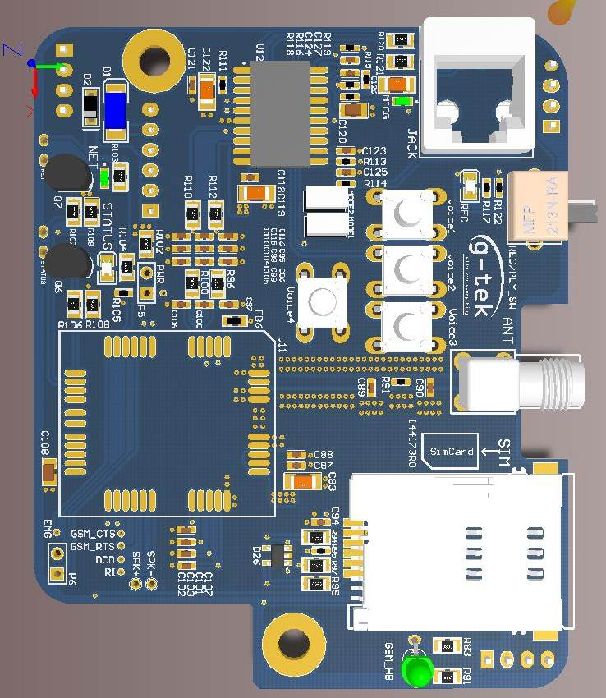
5.1.6 Slave Board Connection
Figure 7 GSM Add-On Connection
The slave board connection diagram is shown in figure 8.
The Ethernet cable from the LAN or network is connected to the “Out-link” connector. And a small TCP/IP cable, to connect the control board to the network, is connected from “Control-Link” to the MAG JACK on the control board
There is a 20 x 4 LCD and Keyboard with five keys available with the Remote Relay device which are pre-installed from the factory.
Relay slave card also came pre-installed.
The Bus Card provides the electrical connection between two boards.
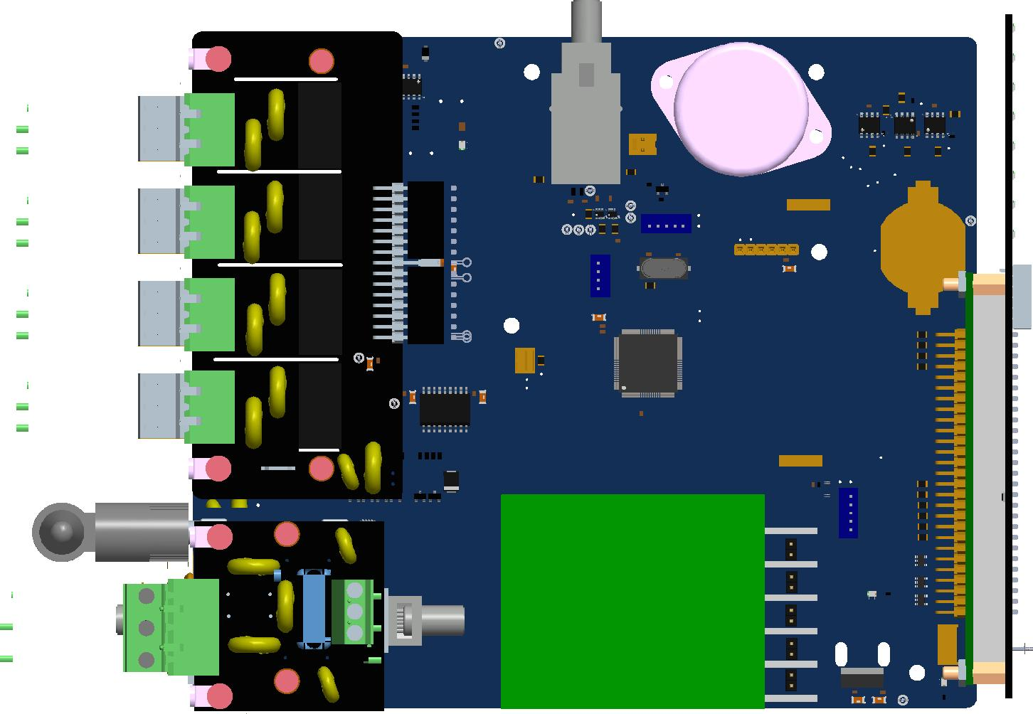
2
5
4
31
11
Figure 5 Control Board Connection

7
6
11
Figure 6 Slave Board Connection

1 - Relay slave card
2 - Bus card (To connect Control board and Relay slave card)
3 - TCP/IP connection on Control Board
4 - Out-link (TCP/IP cable from LAN)
5 - Display and keyboard module
6 - Biometric PCB
7 - Display and Keyboard connector

